Melaleuca ericifolia

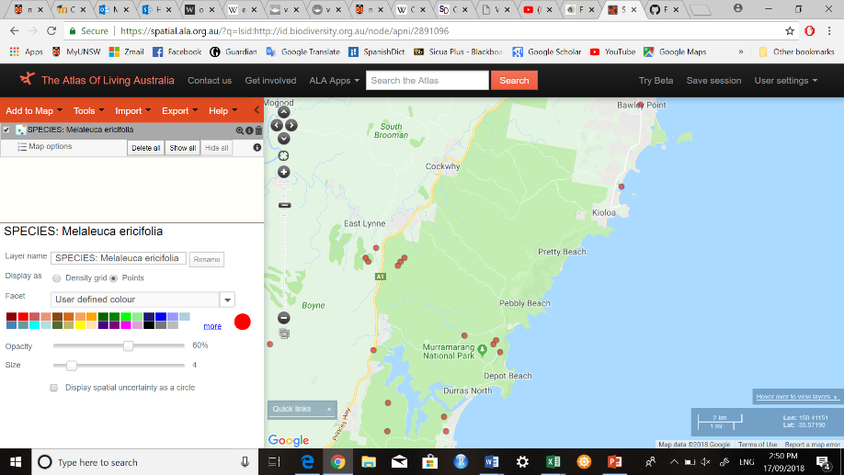

Longitude: 150.301480579 , Latitude: -35.613279618

Melaleuca hypericifolia:  
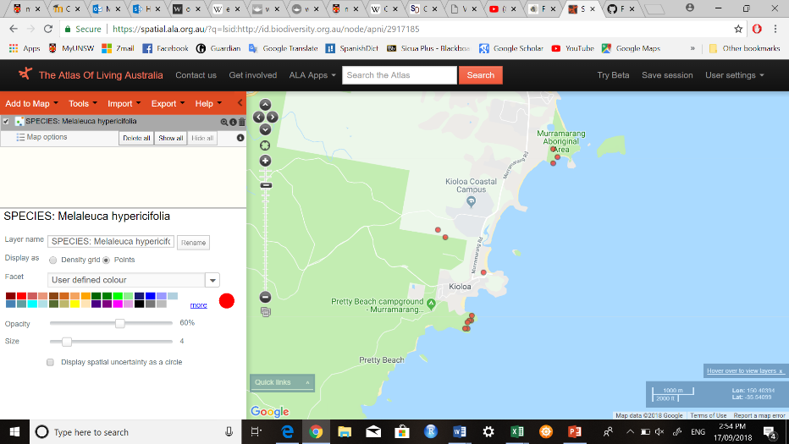

Longitude: 150.37733 , Latitude: -35.56775

Hibbertia dentata:

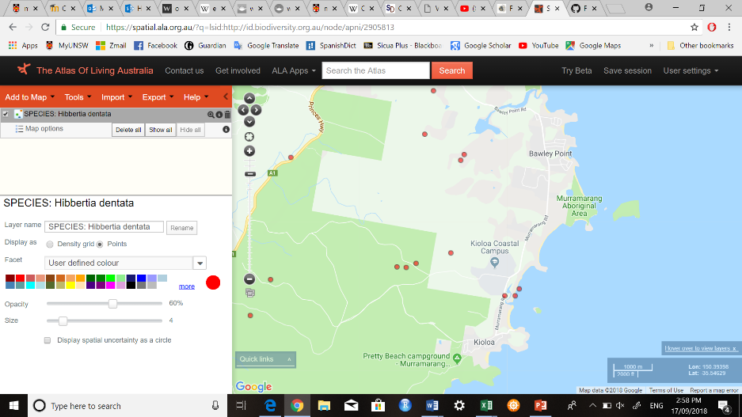

Longitude: 150.35096752 , Latitude: -35.5431726

Crytpocarya:

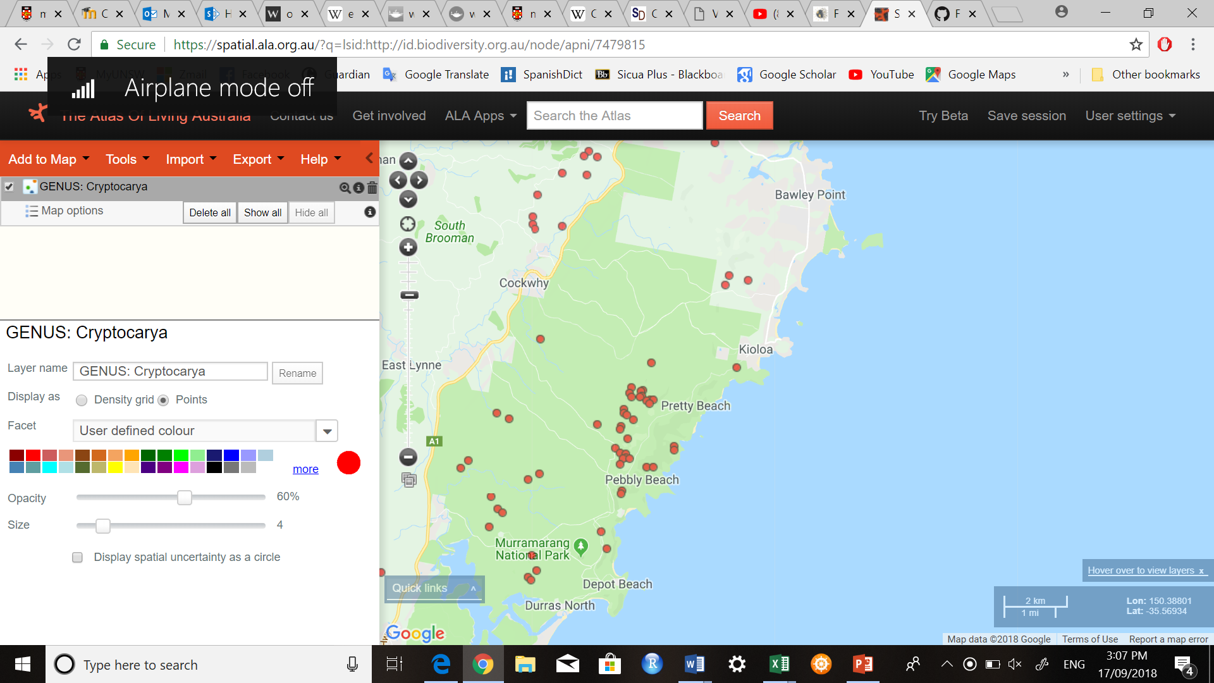

Longitude: 150.364144899 , Latitude: -35.539847172

Endrianda sieberi

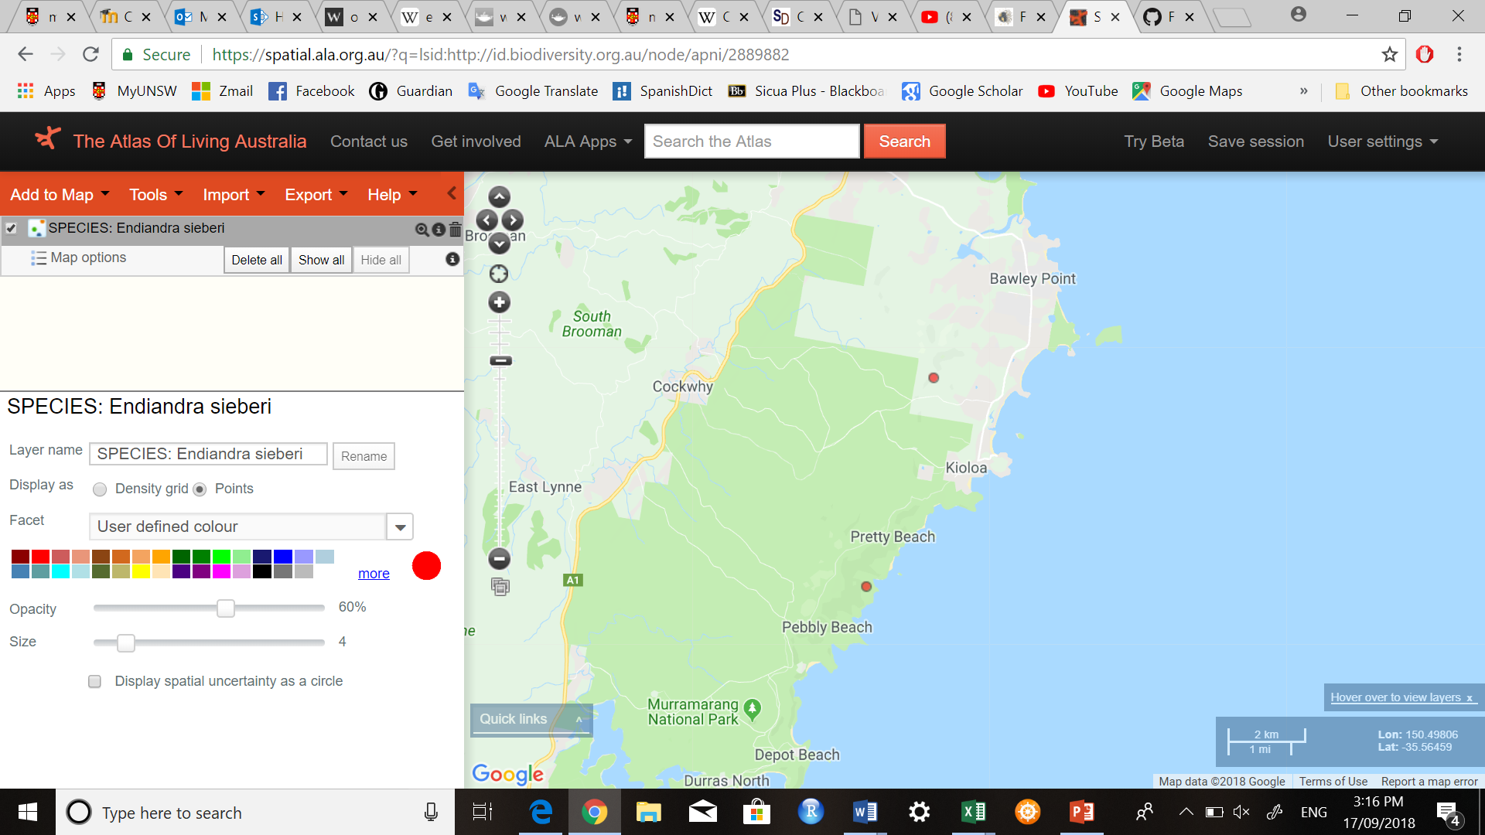

Longitude: 150.364144899 , Latitude: -35.539847172

Leptospermum leavigatum:

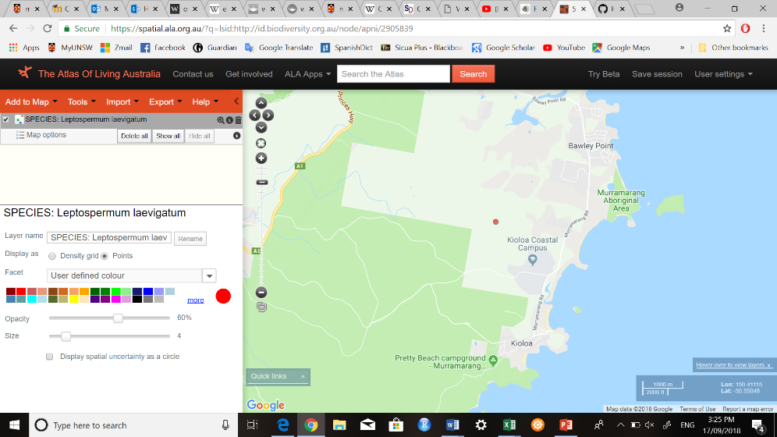

Longitude: 150.3667 , Latitude: -35.5333

Persoonia Mollis

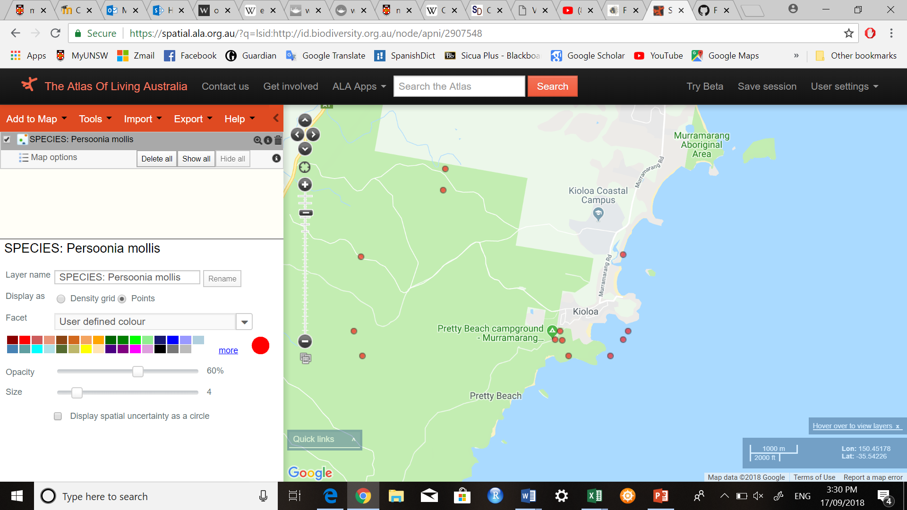

Longitude: 150.3667 , Latitude: -35.5667

Hakea eriantha

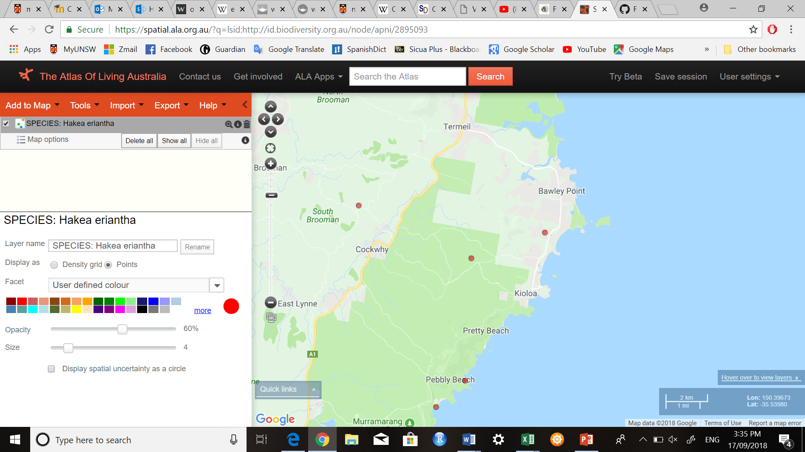

Longitude: 150.344277249 , Latitude: -35.545729367